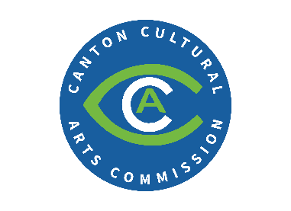
Canton Public Arts Grant Application
Administered by Canton Cultural Arts Commission
Submission Date: __________________________
Applicant Information:
Business Name
Primary Contact Name
Business Address
Property Address (if different than above)
Phone
Email

Funding Amount Requested: ____________________________
____ Matching Grant
____ Non-matching Grant
Property Relationship:
Written authorization from the owner is required if applcant does not own the property.
____ Own ____ Rent ____ Other
Property Owner Name
Property Owner Address
Property Owner Phone

PROJECT INFORMATION
Estimated Completion Cost
Estimated Start Date
Estimated Completion Date
Contractor
Historic Prservation Approval Date
(if applicable)

Project Description Full Project Scope

Required Items for Submission Checklist:
_____ Complete Grant Application
_____ Approval from Historic Preservation Commission
_____ Full Project Budget/Estimate Attached

Required Items Upon Completion of Approved Project:
____ Financial records confirming project expenses incurred
____ Visual inspection by CCAC designee
No work shall commence until final approval granted for project by CCAC. All proposed work must be completed in 90 days unless another timeline is agreed upon in advance between applicant and CCAC. No grant funds will be provided until project completion and appropriate validation of work. Applicant agrees to leave completed project in place for a period of no less than 60 months from date of project completion/grant receipt unless otherwise noted by CCAC.

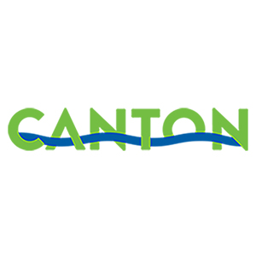
____________________________________________ ___________________________
Signature of Applicant Date
Submit all applications to Kristin Norton at Kristin.Norton@cantonga.gov.

