

CITY OF CANTON, GEORGIA
DOWN PAYMENT ASSISTANCE
PROGRAM MANUAL

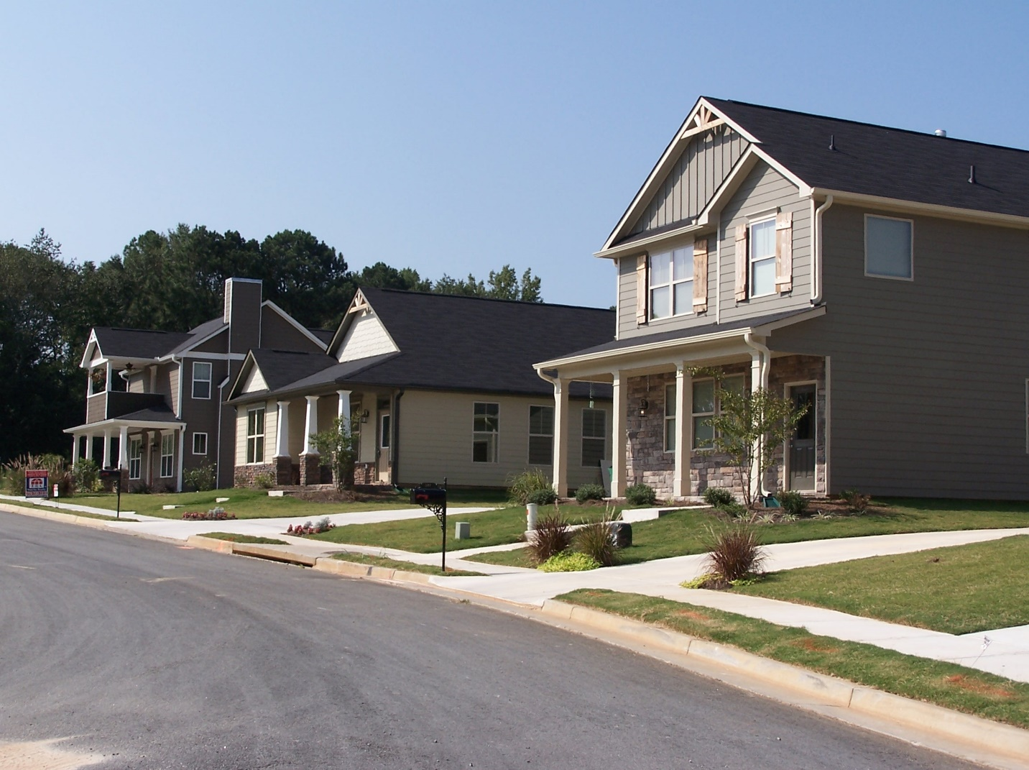

Contents

INTRODUCTION 3
ELIGIBILITY 3
Applicants 3
Eligible Properties 4
Applicable Household Income Limits 4
Maximum Purchase Price 5
Notes About Income Calculations 5
TYPES OF FINANCIAL ASSISTANCE 5
Forgivable Deferred Payment Loans 6
RESTRICTIONS 7
Eligible Use of Funds 7
Purchase Price Limitation 7
Restriction on Loan Subordination 7
Restriction on Assumption of Loan 7
ROLES AND RESPONSIBILITIES 7
The Role and Responsibility of the Applicant 7
Role and Responsibility of Financial Institutions 8
Role and Responsibilities of the City of Canton 10
The Role and Responsibility of the Closing Attorney 11
APPENDIX 12

INTRODUCTION
The City of Canton offers financial assistance to low to moderate-income, first-time homebuyers through the City’s Down-Payment Assistance Program. Under the program, eligible down-payment and closing costs are paid for with funds provided by the City of Canton.

ELIGIBILITY

Applicants
1. The applicant must be a “First-Time Homebuyer” which is defined as under federal regulations as:
a. An individual or his or her spouse who have not owned a home during the three- year period prior to the purchase of a home with assistance under this program, or
b. A person who is a displaced homemaker which is defined as: An adult who has not worked full-time, for a full year in the labor force for a number of years but has, during such years, worked primarily without remuneration to care for the home and family and is unemployed or underemployed and is experiencing difficulty obtaining or upgrading employment, or
c. A person who is a single parent defined as an individual who is unmarried or legally separated from a spouse (documentation must be provided for separation or divorce); and has one or more minor children of whom the individual has custody or joint custody or is pregnant.
2. The applicant’s total household income must be within the U.S. Department of Housing & Urban Development’s (HUD) Area Median Income Limits for the Atlanta-Sandy Springs-Roswell Metropolitan Statistical Area (MSA). The total annual income cannot exceed eighty percent (80%) of the area median income depending on family size.
3. The applicant must present any court-ordered documentation illustrating custody for surrogate family members (e.g., grandchildren, nieces, nephews, cousins, etc.).
4. The applicant must have successfully completed a department-approved home buyer education program prior to purchasing a house with assistance from the program.
5. The applicant must be a homebuyer who agrees that the purchased home will serve as the applicant’s sole place of residency and not serve as a rental or commercial facility.

Eligible Properties
1. The property must be a one (1) unit single family dwelling (attached or detached) design for residential use and located within the City of Canton and intended for owner occupancy. Unless the tenant is the borrower, financial assistance program funds cannot be used towards the purchase of a property which is occupied by a tenant at the time the sales contract is signed.
2. The property to be purchased must meet the requirements of the applicable housing and building codes and ordinances. Applicable Household Income Limits The table below shows the household income limits applicable to the Down-payment Assistance Program

Applicable Household Income Limits
The table below shows the household income limits applicable to the Down-Payment Assistance Program.
Income Limits by Household Size for the City of Canton, Georgia,
2023 Home Income Limits
Household Size |  | Household Income Limits 2023
Size of Family | 30% of Median | 60% of Median | 80% of Median
1 | $22,600 | $45,180 | $60,200
2 | $25,800 | $51,600 | $68,800
3 | $29,050 | $58,080 | $77,400
4 | $32,250 | $64,500 | $86,000
5 | $34,850 | $69,660 | $92,900
6 | $37,450 | $74,820 | $99,800
7 | $40,000 | $79,980 | $106,650
8 | $42,600 | $85,140 | $113,550
Source: U.S. Department of Housing and Urban Development, Income Limits for Atlanta-Sandy Springs-Roswell GA. HUD Metro 2024
Note: Income limits are subject to change annually

Maximum Purchase Price
The maximum purchase price is as follows for the Atlanta-Sandy Springs-Roswell GA. HUD Metro, Cherokee County (2024):
Unit # | Federal Home Prices
 | FHA | Fannie Mae/Freddie Mac
1 unit | $649,750 | $766,550
2 unit | $831,800 | $981,500
3 unit | $1,186,350 | $1,123,900
4 unit | $1,474,400 | $1,396,800
Median Value | $565,000

Notes About Income Calculations
Total annual household income cannot exceed 80% of the area median income figure, depending on family size, to be eligible for assistance. The total household income is determined by adding up the annual wages, salaries, governmental and non-governmental benefit disbursements, court ordered child support, alimony, and stock dividend payments of each member of the household listed on the application where these items apply. This also applies to children who are employed full or part-time.
If any individual whose name(s) appear on the application has custodial responsibilities for other member(s) of the household, submission of a “Custodial Order” from the appropriate court, granting full custodial responsibilities to the applicant, will be required at the time the application is submitted. This is necessary to accurately document the number of people in the applicant’s household.
** INCOME WILL BE CALCULATED ACCORDING TO HUD’S GUIDELINES**

TYPES OF FINANCIAL ASSISTANCE
The type of financial assistance available is Deferred Forgivable Payment. The total maximum amount of assistance available to any one applicant is $12,500.00.

Forgivable Deferred Payment Loans
Eligible Property: Single-family home located in the City of Canton Amount of Assistance: Minimum of $500.00 up to a maximum of $12,500.00.
Repayment: The full amount of the deferred payment loan is forgiven after the fifth anniversary of the purchase if the applicant continues to own and reside in the home, and the use of the property remains residential. Applicant must submit every year documentation proving residency, such as power bill, gas bill, water bill, etc. Applicant must attend a post homeowners counseling class prior to the five year “forgivable” loan period being completed. Completion of class certificate must be submitted to the City of Canton. Failure to provide the requested information can result in the lien remaining on the home until proper documentation is submitted.
Within the five (5) year period, twenty (20%) of the amount which has been determined to be forgiven will be subtracted to achieve the total amount to be forgiven (see chart below)

Year # |  | Annual Amount  Re-Paid ($12,500)
Repayment after year | 1 | $10,000.00
Repayment after year | 2 | $7,500.00
Repayment after year | 3 | $5,000.00
Repayment after year | 4 | $2500.00
Repayment after year | 5 | 0

RESTRICTIONS

Eligible Use of Funds
Financial assistance made available under the Down-payment Assistance Program may only be used to cover down-payment assistance and closing costs. Examples of eligible costs include financing fees, appraisals, legal fees, and recording costs.

Purchase Price Limitation
According to HUD regulations, the purchase price for a unit assisted under this program cannot exceed 95% of the median purchase price of a single-family home in the Atlanta-Sandy Springs-Roswell (MSA), or FHA mortgage limits for the MSA

Restriction on Loan Subordination
During the first five (5) years of the loan period, loan subordination requests will not be processed or approved by the City of Canton.

Restriction on Assumption of Loan
A loan made under the Down-payment Assistance Program is not assumable. The outstanding balance must be paid by the borrower upon the sale or transfer of the property.

ROLES AND RESPONSIBILITIES
Program applicants (i.e., qualified first-time homebuyers), financial institutions, closing attorneys and the City of Canton have interrelated roles and responsibilities. It is important that all parties understand their responsibilities to assume timely processing of each application for assistance under the Down-payment Assistance Program.

Role and Responsibility of the Applicant
1. Applicant must submit to the lender all information to be included in the DPA application package.
2. Applicant attends an interview session with City of Canton staff. During the interview staff will review documents which the applicant will be required to submit at the time of the interview. These documents include, but are not limited to the following:
- Proof of Identity (Driver’s License, Approved State Identification Card, Voters Registration Card). - Credit report
- Social Security cards for everyone that will be residing in the home.
- Two months of bank statements.
- One (1) years of income tax returns (Federal, State & City).
- Four (4) consecutive pay stubs and any other supportive income information, such as child support, social security benefit documentation, etc.
- Marriage certificates, divorce papers or legal separation papers.
- Court custodial order(s) for surrogate family members and individuals.
Note: Failure of an applicant to attend the scheduled interview session, and/or failure to submit the required documentation, will result in a delay or postponement in the application review process.
3. Applicant is required to attend and complete a qualified homebuyer education/prepurchase housing counseling program. Upon completion of the program, the applicant is to submit a Certificate of Completion to their financial institution.
4. Applicant will be responsible for providing contributions to the purchase of the home. Purchaser will provide the following according to the income guidelines.
Income Limits | Contribution Amount
30% | $500.00
60% | $750.00
80% | $1,000.00

Role and Responsibility of Financial Institutions
1. Financial institution (i.e., the lender qualifying an applicant for a home mortgage loan) determines the potential homebuyer’s financial ability to purchase the desired property.
2. Because financing is limited under the Down-payment Assistance Program, lenders are to make every effort to qualify clients for the highest loan-to-value ratio on the client’s first mortgage.
3. Lender submits the required documentation outlining the applicant’s request for financial assistance. The required documents include, but are not limited to, the following:

No. | Description of Items Requested
1 | Contract Information Sheet outlining – Seller’s Name; Address; Phone Number; Closing Attorney’s Info; Real Estate Agent; Buyer’s Agent; Appraisal Price; Sales Price; Requested DPA Amount. All info on Lender’s Letterhead
2 | Form 1033 – UNIFORM RESIDENTAL LOAN APPLICATION (Signed by Borrower)
3 | AHCD – Homeownership Financial Assistance Application (Completed)
4 | Verification of Employment
5 | Verification of Income – Paystubs (2 consecutive months/W-2 form/Income Tax Return
6 | Loan Estimate
7 | Debt to Income worksheets
8 | Appraisal Report (In Color)
9 | Purchase/Sale Agreement (Sales Contract)
10 | Credit Report
11 | Copy of Driver’s License  Copy of Social Security Cards of all that will reside in property
12 | Proof of Earnest Money Revd. (min. $500.00 according to income)
13 | Proof of Homeowner’s Insurance
14 | Copy of Homeowner’s Insurance

4. All applications should be uploaded to Ken Patton, Housing Initiatives Director (ken.patton@cantonga.gov). Lender must submit an application that contains all of the required documents. The application review process will not begin until all the required documents are submitted. To avoid delays in the review of an application, lenders are advised to submit all the required documents at the same time.
5. Lender must arrange with the City of Canton for the initial physical inspection of the property to be assisted under the program. The lender is the only entity authorized to request an inspection or re-inspection of a property. When contacting the department, a lender should provide the name and telephone numbers of the seller and the real estate agent and available dates for access to the property.
6. Lender is responsible for informing the seller and/or their representative that the property is ready to be inspected by City staff.
7. Lender (via the seller/realtor) bears the responsibility in addressing and completing all the repairs that have been noted by inspectors following a physical inspection of the property to be assisted under the program.
8. Lender contacts the City to arrange for the re-inspection of a property, if necessary.
Note: If a home does not pass inspection on the first visit by the inspectors, a hundred ($100.00) dollar payment will be imposed each time the property does not pass inspection and must be paid prior to the second visit and any thereafter. Cash payments will not be accepted. Money orders and checks are the acceptable forms of payment, payable to the “City of Canton”.
Note: All properties built prior to 1978 must be inspected/ tested for the presence of lead-based paint hazards. Evidence of the inspection, testing completion of any necessary abatement is required prior to the funding of the loan.
**25 BUSINESS DAY APPROVAL TIME ALLOTTED FROM A CITY SIGNED AGREEMENT PACKAGE SUBMISSION**

Role and Responsibilities of the City of Canton
1. Make every effort to complete the application review process in a minimum of fifteen (15) days. Situations do arise that cause delays in the timely processing of an application. Some of the typical reasons for delays in processing an application includes the following:
a. Failure of Lender to submit all the required documents.
b. Failure for the desired property to pass the physical inspection requirement of the program.
2. Assure compliance with the applicable federal rules, regulations, policies and procedures in the administration and management of the Down-payment Assistance Program.
3. Convey in writing to the lender whether an application has been approved for assistance.
4. Conduct an interview with the applicant during the application review process.
5. Conduct a physical inspection using HQS (Housing Quality Standards) of the property to be assisted under the program. The purpose of the inspection is to assure that the home meets the applicable needs and ordinances. City inspection staff personnel will contact the appropriate parties to conduct the physical inspection. It is imperative that City inspectors conduct the inspections without interference. Inspectors have been instructed to limit their comments in written form. Their notes/comments will be placed on a triplicate carbonless form. A copy of these notes/comments will be submitted to the seller, realtor, and the financial institution. Copies of the Property Inspection Checklist and Inspection Worksheet are included as attachment to this manual.
6. Upon approval of an application for assistance, complete the necessary legal documents and transmit the same to the attorney handling the sale/purchase of the property.
7. To avoid confusion and to expedite the application review process, City staff will only discuss the status of an application, and the scheduling of the property inspection, with the lender who submits the application package. Department staff will not discuss the status or contents of an application package with realtors, the seller and/or the potential homebuyer.

The Role and Responsibility of the Closing Attorney
1. Closing attorney will provide the City of Canton with a copy of all closing documents within twenty-four hours of the loan closing.
2. If a closing attorney or law firm fails to furnish copies of the closing documents in a timely manner on two separate occasions, a guarantee of funds letter will be issued in lieu of a check for all subsequent closings. In such cases, the City of Canton will then issue a check after receiving copies of the closing documents.

APPENDIX
Schedule of Items to Be Inspected
Item | Requirements
Ceilings | Free of severe bulging, large cracks and holes or loose falling materials
Walls | Free of severe bulging, large cracks and holes or loose falling materials
Floors | Free of large cracks and holes, warped floorboards and covering causing trip hazards
Windows | Every window is to be in good condition possessing screens free of slits and holes able to close and keep out weather and free of cracked and broken window panes
Paint | No peeling or chipping paint
Locks | Good working condition for doors and windows
Doors | Free of peeling, sticking, large cracks and holes Screens on patio doors
Roofs, Gutters & Downspouts | No evidence of leaking, free of large cracks and holes and properly attached to the building
Stairs (Interior) | Handrails properly secured and steps free of trip hazards
Attic Stairway | Handrails properly secured, steps free of trip hazards and “Batt” insulation installed in step cavities
Steps (Exterior) | Handrails properly installed (three steps or more) or secured. Steps are to be free of trip hazards
Handrails | Evidence of properly installed handrails for porches, balconies or decks 30” above the ground
Foundation | No evidence of leaking
Sewage | No evidence of leaking and properly connected to public or private sewage disposal system
Chimneys | No evidence of cracks, defects, leaning or missing bricks
Electric | Connected, operational and in good condition no evidence of frayed or faulty wiring, every receptacle or switch is to be fully operable. ”GFI” outlets are to be fully operable and installed in interior wet areas (Kitchens & Bathrooms) and exterior wall areas
Plumbing | Pipes in good condition no evidence of leaking. No serious rusting around drains, faucets and pipes. Operable water fixtures, faucets, drains, toilets, showers and tubs (Kitchens, bathrooms, exterior hose bibs, etc.)
Cooling Systems | Connected, operational and in good condition, no evidence of leaking or malfunctions
Heating Systems | Connected, operational and in good condition, no evidence of leaking or malfunctions
Water Heater | Connected, operational and in good condition, no evidence of leaking or malfunctions
Exterior Lights | Connected, operational and in good condition
Smoke Detectors | Connected, operational and in good condition
Garbage, Vegetation, Rodents | No large piles of trash, vegetation, rodent and insect infestation which can pose a threat to the building and inhabitants
Bathroom – Tub/Shower Areas | Tub/Shower operable w/ hot and cold running water, no loose or crack tiles.
Bathroom – Medicine Cabinet & Mirrors | Medicine cabinet installed properly, no rust or cracked or broken glass. Mirrors no evidence of cracks, or broken glass
Appliances | Stove, oven and refrigerator in good working condition. If appliance are not present letter must be submitted indicating delivery date
Pollution | No evidence of carbon monoxide, sewer gas, etc.

Lead-Based Paint Hazards
All properties securing financial assistance which were built prior to 1978 must be inspected for lead-based paint and the appropriate action must be taken. Evidence of the inspection, completion of any necessary abatement actions is required prior to the funding of the loan.
Description of Financial Assistance Offered
“Conditional Deferred Payment Loans” are issued to qualified program participants through an application process and a qualifying process, which determines the eligibility of the potential program participant. Financial assistance is offered in the following manner:
- The minimum amount of assistance offered is five hundred ($500.00) dollars.
- The maximum amount of assistance offered is ten thousand ($12,500.00) dollars. The loan will be “Forgiven” after the conditions listed below are met.
1. The fifth-year anniversary date has occurred.
2. The homeowner resides in the home after five (5) years.
3. The ownership of the property does not change, and the use of the property remains residential after five years.
4. Within the five (5) year period within each calendar year at the anniversary date of the initiation of the loan, twenty (20%) of the amount which has been determined to be forgiven will be subtracted to achieve the total amount to be forgiven. Please refer to the chart below:

Year # |  | Annual Amount  Re-Paid ($12,500)
Repayment after year | 1 | $10,000.00
Repayment after year | 2 | $7,500.00
Repayment after year | 3 | $5,000.00
Repayment after year | 4 | $2,500.00
Repayment after year | 5 | 0

Canton Down Payment Assistance Program Partners
Renasant Bank
Citizens Bank of Pickens County
Regions Bank
United Community Bank
Credit Union of Georgia
Acopia Home Loans
Chase Home Loans

